[](https://www.genmymodel.com/)

# Machine model

theion

Author: Sami dhiab

Date: 2022-01-03

# Machine model (Model)

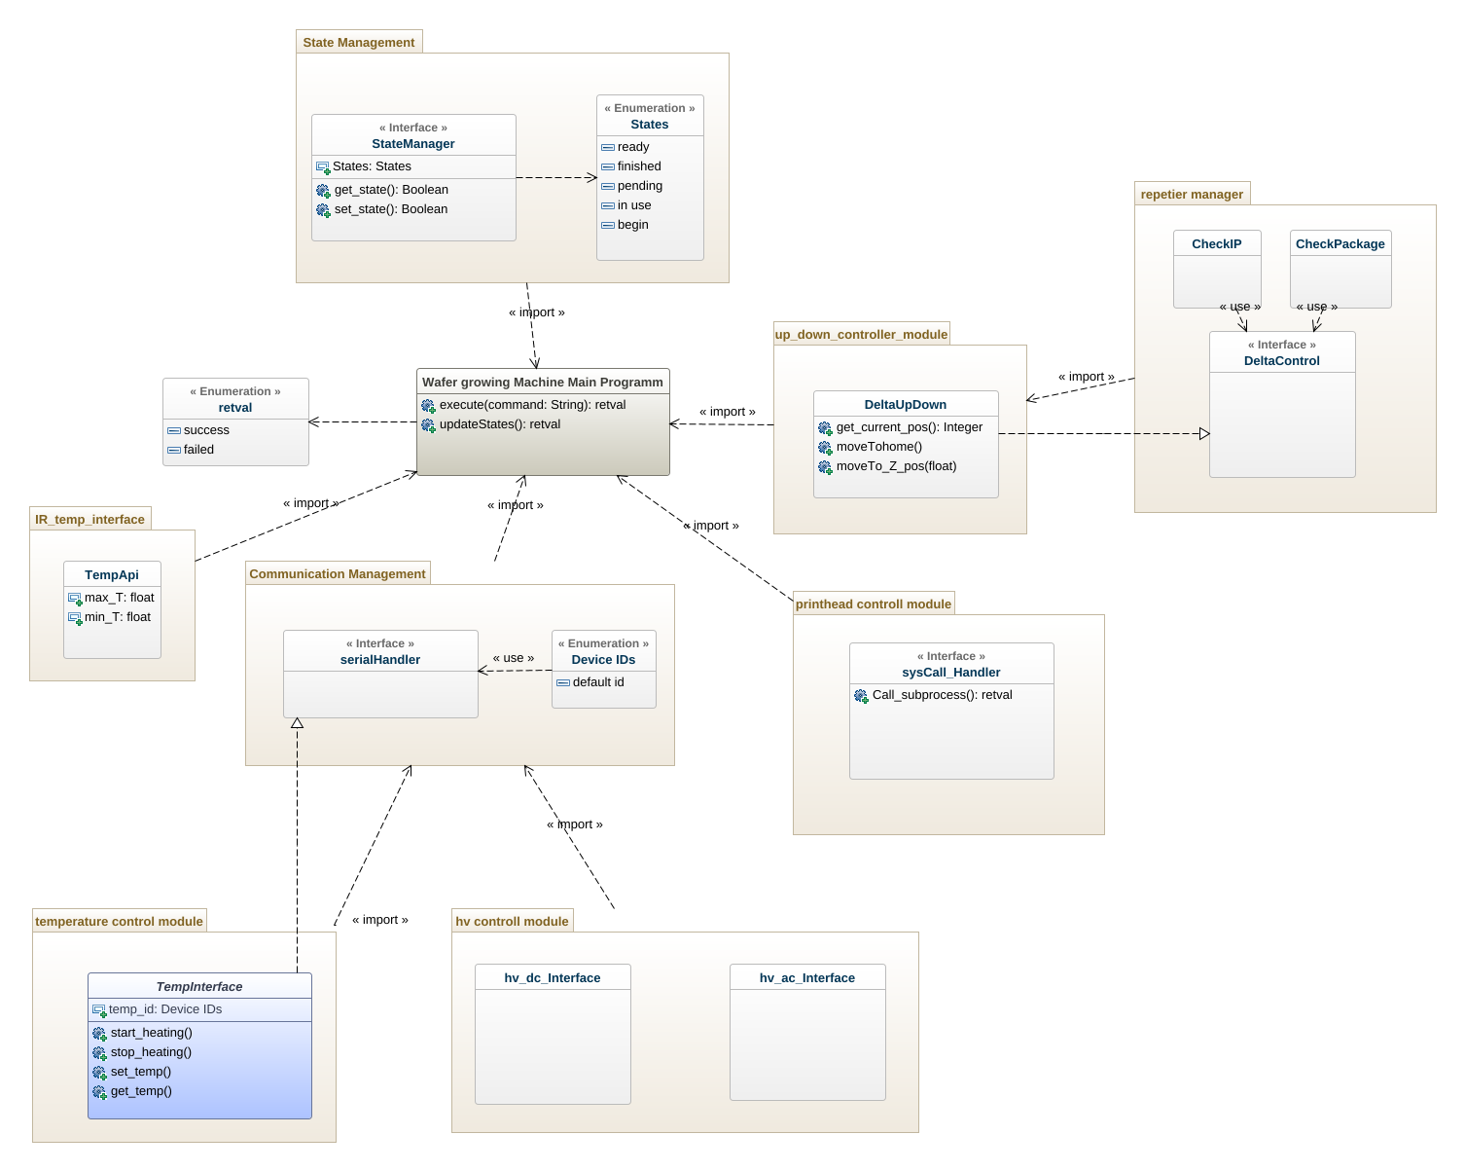

machine-class-diagram

## 1. StateManager (Class)

In Machine model

| Attributes |
| --- |
| States : States [1] |

| Operations |
| --- |
| get_state : Boolean |
| set_state : Boolean |

| Associations |
| --- |
| Wafer growing Machine _StateManager - wafer growing Machine : Wafer growing Machine Main Programm [*] - see definition |

## 2. Wafer growing Machine Main Programm (Class)

In Machine model

| Operations |
| --- |
| execute : retval  - command: String[1] |
| updateStates : retval |

| Associations |
| --- |
| Wafer growing Machine _StateManager - stateManager : StateManager [1] - see definition |

## 3. float (DataType)

In Machine model

## 4. float2 (DataType)

In Machine model

## 5. retval (Enumeration)

In Machine model

## 6. retval (Enumeration)

In Machine model

* success
* failed

## 7. Communication Management (Package)

In Machine model

### 7.1. Device IDs (Enumeration)

In Machine model::Communication Management

* default id

### 7.2. serialHandler (Interface)

In Machine model::Communication Management

## 8. IR_temp_interface (Package)

In Machine model

### 8.1. TempApi (Class)

In Machine model::IR_temp_interface

| Attributes |
| --- |
| max_T : float [1] |
| min_T : float [1] |

## 9. State Management (Package)

In Machine model

### 9.1. StateManager (Interface)

In Machine model::State Management

| Attributes |
| --- |
| States : States [1] |

| Operations |
| --- |
| get_state : Boolean |
| set_state : Boolean |

### 9.2. States (Enumeration)

In Machine model::State Management

* ready
* finished
* pending
* in use
* begin

## 10. hv controll module (Package)

In Machine model

### 10.1. hv_ac_Interface (Class)

In Machine model::hv controll module

### 10.2. hv_dc_Interface (Class)

In Machine model::hv controll module

## 11. printhead controll module (Package)

In Machine model

### 11.1. Class (Class)

In Machine model::printhead controll module

### 11.2. sysCall_Handler (Interface)

In Machine model::printhead controll module

| Operations |
| --- |
| Call_subprocess : retval |

## 12. repetier manager (Package)

In Machine model

### 12.1. CheckIP (Class)

In Machine model::repetier manager

### 12.2. CheckPackage (Class)

In Machine model::repetier manager

### 12.3. Class (Class)

In Machine model::repetier manager

### 12.4. DeltaControl (Interface)

In Machine model::repetier manager

## 13. temperature control module (Package)

In Machine model

### 13.1. (Class)

In Machine model::temperature control module

### 13.2. DeviceCard (Class)

In Machine model::temperature control module

Extends

* TempInterface - see definition

### 13.3. ExtensionBoard (Class)

In Machine model::temperature control module

Extends

* TempInterface - see definition

| Associations |
| --- |
| ExtensionBoard_Card - cards : TempInterface [*] - see definition |

### 13.4. TempInterface (Class)

In Machine model::temperature control module

Implements

* serialHandler - see definition

| Attributes |
| --- |
| temp_id : Device IDs [1] |

| Operations |
| --- |
| start_heating |
| stop_heating |
| set_temp |
| get_temp |

| Associations |
| --- |
| ExtensionBoard_Card - extensionBoard : ExtensionBoard [1] - see definition |

## 14. up_down_controller_module (Package)

In Machine model

### 14.1. DeltaUpDown (Class)

In Machine model::up_down_controller_module

Implements

* DeltaControl - see definition

| Operations |
| --- |
| get_current_pos : Integer |
| moveTohome |
| moveTo_Z_pos  - Z_pos: float[1] |